|  |
| --- |
| | |



|  |  |
| --- | --- |
|  | How to order an item on Flipkart |

Copyright © 2010 by XYZ

Content published on this website (digital downloads, images, texts, graphics, logos) is the property of XYZ and/or its content creators and protected by international copyright laws. The entire compilation of the content found on this website is the exclusive property of XYZ, with copyright authorship for this compilation by XYZ.

All rights reserved. No part of this publication may be reproduced, distributed, or transmitted in any form or by any means, including photocopying, recording, or other electronic or mechanical methods, without the prior written permission of the publisher, except in the case of brief quotations embodied in critical reviews and certain other non-commercial uses permitted by copyright law. For permission requests, write to the publisher, addressed “Attention: Permissions Coordinator,” at the address below.

Imaginary Press  
1233 Pennsylvania Avenue  
San Francisco, CA 94909  
www.imaginarypress.com

**Revision History**

|  |  |  |  |  |  |  |
| --- | --- | --- | --- | --- | --- | --- |
| Date |  | Author |  | Revision |  | Summary of changes |
| 11-Jan-2023 |  | Arun L |  | 1.0 |  | Initial Release |

Contents

Introduction 3

Scope 3

Pre-requisites 3

Abbreviation 3

How to order an item in Flipkart 3

Flipkart Menu 3

Make an order in Flipkart 4

# Introduction

Flipkart is the world`s largest e-commerce site which acts as a marketplace to sell books, electronic items, hardware, and many more. This section describes the essential features of the Flipkart landing page. It enables you to browse and shop items on the Flipkart website.

# Scope

This document provides the set of instructions to order an item on Flipkart. Follow the step-by-step instructions for a hassle-free Flipkart shopping experience.

# Pre-requisites

The user must have a Flipkart account for purchasing.

# Abbreviation

This section will provide the expansion of the abbreviations used in this document.

PC – Personal Computer.

OTP – One Time Password.

# How to order an item in Flipkart

This section provides you the detailed instructions to order an item on the [Flipkart website](https://www.flipkart.com/).

## Flipkart Menu

When you sign in, Flipkart displays the Header menu on top of the web page. The table that follows gives an overview of actions that you can perform with the buttons on the header menu.

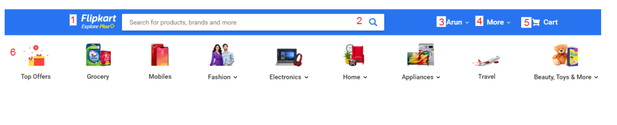

|  |  |  |
| --- | --- | --- |
| **Annotation** | **Menu** | **Description** |
| 1 | Navigation Logo | Clicking this logo redirects you to the Flipkart home page. |
| 2 | Search Bar | You can search for items that are listed on the Flipkart website. |
| 3 | Account Settings | All your account-related settings are listed in this menu. You can view and change your account settings from this menu. |
| 4 | More | This menu provides additional information such as the link to download the application, 24X7 customer supports, and many more. |
| 5 | Shopping Cart | The items you added to your shopping cart appear in this menu. |
| 6 | Menu Category | Items are listed in this menu based on the category. You can navigate through the menu according to your likes. |

## Make an order in Flipkart

1. Open the web browser of your choice from your laptop or PC.
2. Open the [Flipkart website](http://www.flipkart.com/). Click the **Login** Button.

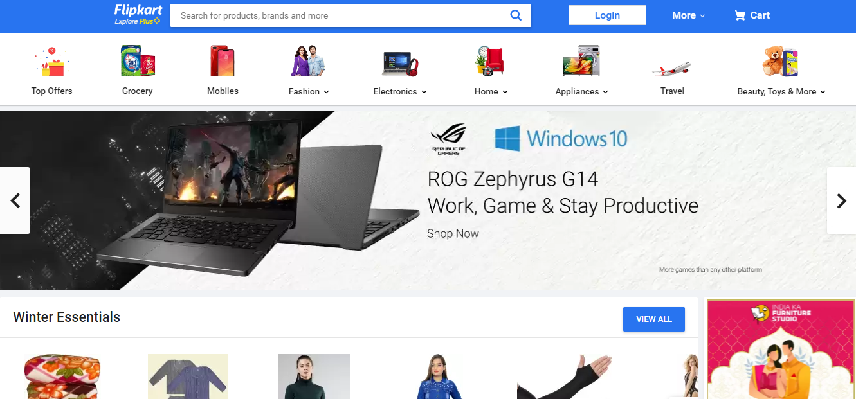

**Figure1: Flipkart Home page.**

1. Provide the registered email id/ mobile number and password in the text field and click the **Login** button.

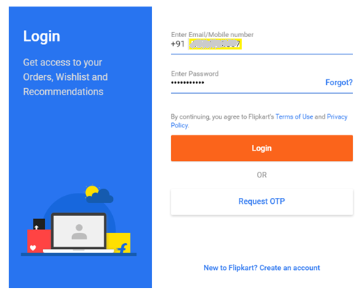

**Figure 2: Login Credentials**

**Note**: As an alternate, you can log in by requesting OTP to the registered mobile number.

1. In the **Search Bar**, provide the item you wish to purchase. For example, if you wish to purchase an Apple iPhone 11. Provide Apple iPhone 11 in the **Search Bar**.
2. The search results will display that matches the search keyword. The product description and the price details of the Apple iPhone 11 are displayed.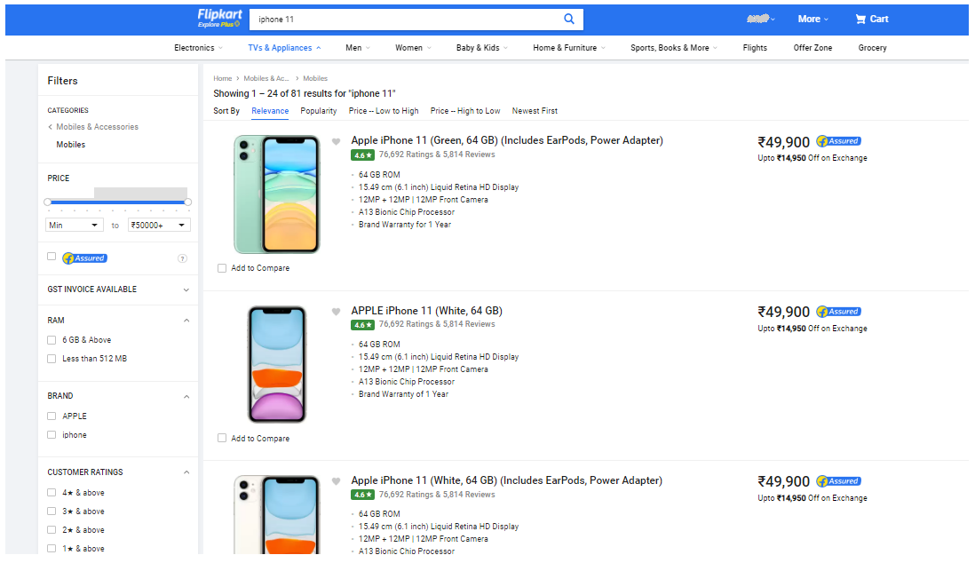

**Figure 3: Search Bar**

1. Select the appropriate item that you wish to purchase.
2. Click the **Buy Now** button.

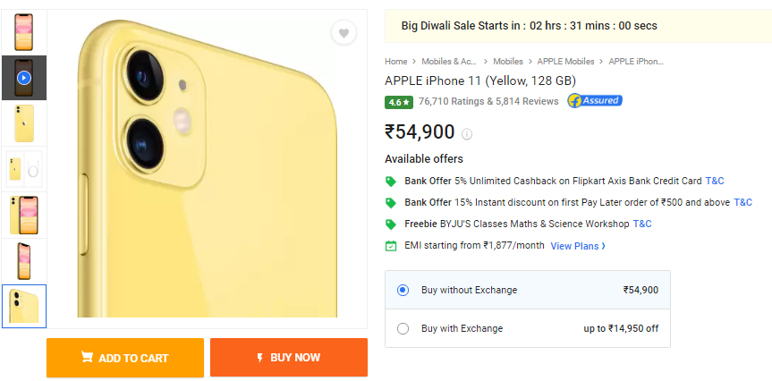

**Figure 4: Buy now**

1. Select a delivery address. If you wish to provide a new address, click the **Add a new address** button and click the **DELIVER HERE** button.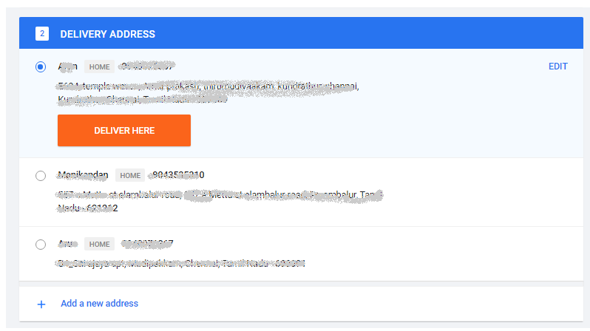

**Figure 5: Delivery Address**

1. On the order summary appears, click the **CONTINUE** button.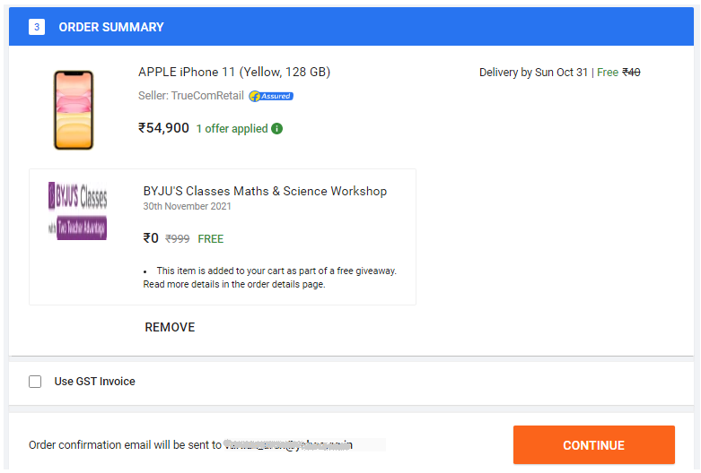

**Figure 6: Order summary**

1. Select the payment option of your choice and click the **Continue** button.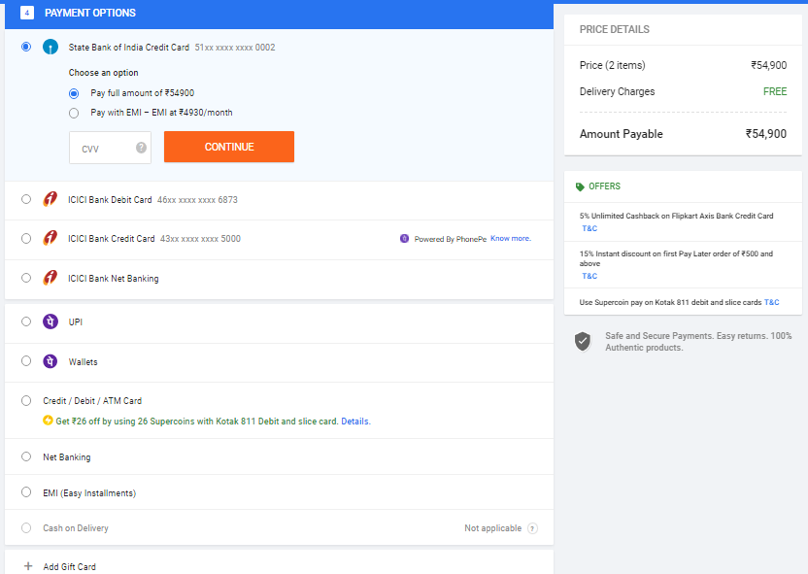

**Figure 7: Payment Option Page**

1. You will be redirected to the selected payment gateway page. Once you finish the purchase, you will receive a confirmation message for an order placed successfully with the estimated date of delivery.
2. Click the **Logout** button to close your session. This will ensure that no one else can access your account.